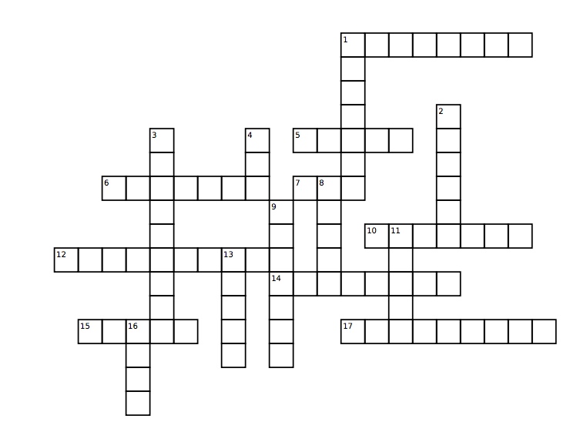

Name:___________________

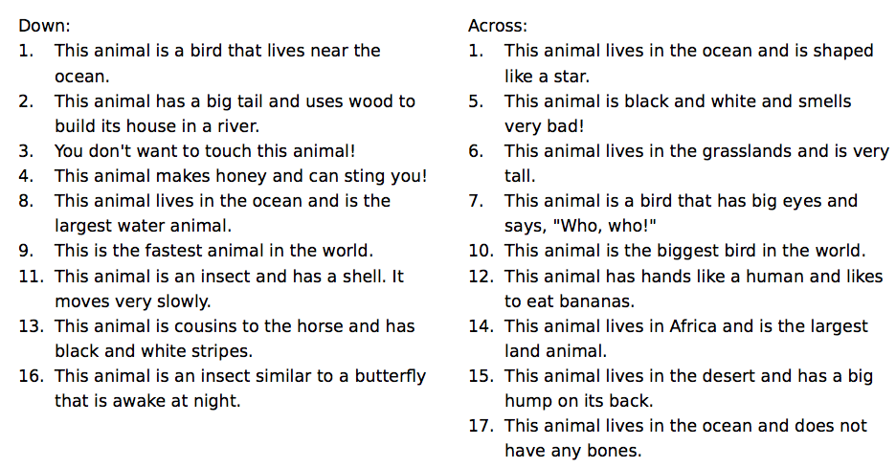

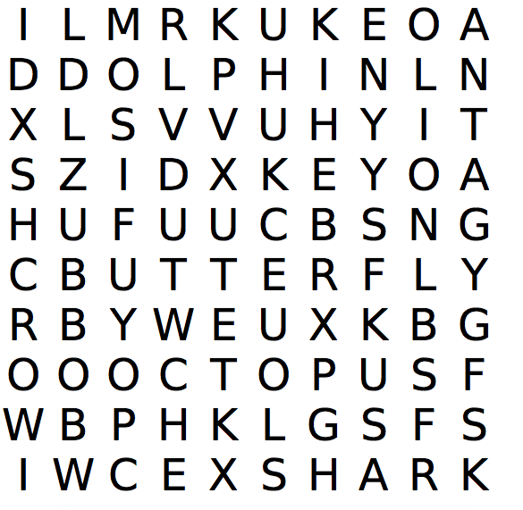

1. When I was born I was a caterpillar. Now I am a ______________.

2. I am a bird that is all black. I am a ____________.

3. I am a big cat. I have a lot of hair around my neck. I am a _______.

4. I live in the ocean and have 8 legs. I am a ___________.

5. I live in the ocean but I am a mammal. I have fins and swim really

fast. I am a __________.

6. I live in the ocean and am a carnivore. I have very sharp teeth. I am

a ___________.

7. I am a very small insect. I build my house with sand. I am an _____.