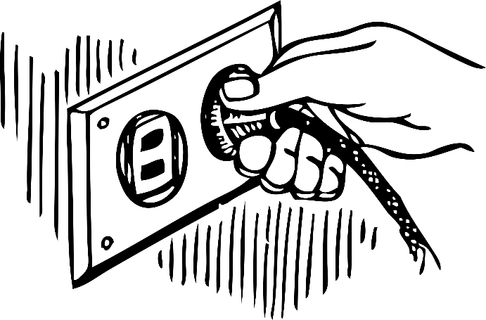
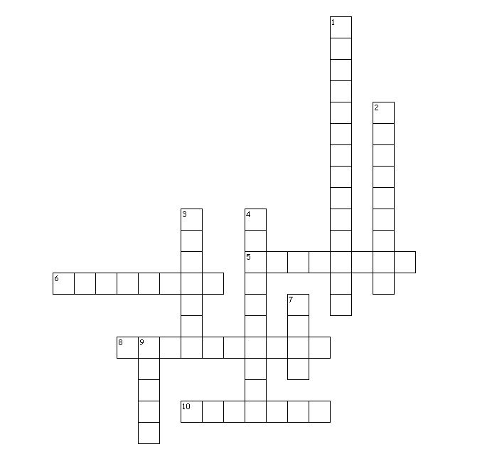
Energy Crossword Puzzle
Across
5. a type of stored energy that can be released, usually by burning
6. a word used to describe how energy can move from one object to another
8. a type of energy related to the flow of charges
10. a type of energy that is stored in the core of an atom

Down
- when energy changes from one type into another
- a type of energy that is due to an objects position
- a type of energy that is involved in movement
- the total of kinetic and potential energy
7. a type of energy that is related to the vibration of an object’s particles
9. a type of energy that travels in waves and is directly used by plants

Energy Crossword Puzzle

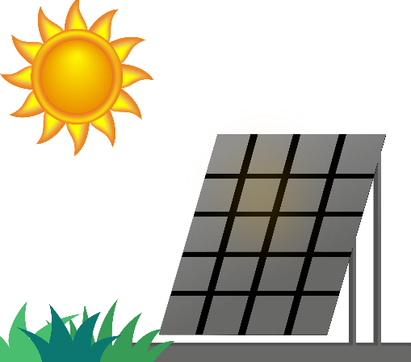
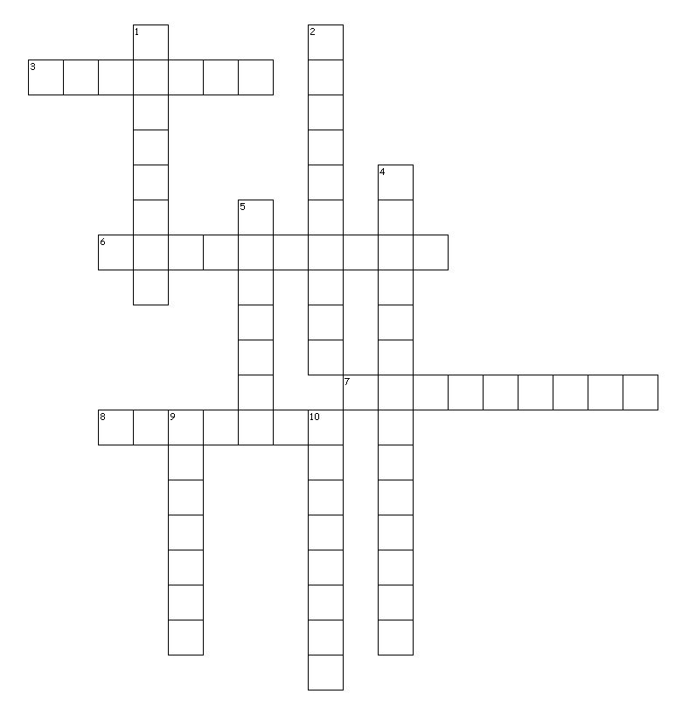

Across
3. the kinetic energy inside an object’s atoms or molecules, causing the object to vibrate
6. the sum of an object’s kinetic and potential energy
7. the energy an object has due to its position or structure
8. the energy an object has due to its motion

Down
- this is what happens when energy is passed on from one object to another
- a type of energy related to the flow of charges
4. this is what happens when one type of energy changes into another type
- is the type of energy that travels in the form of electromagnetic waves
9. the energy that can be released when atoms are split
10. the type of energy stored in the bonds of atoms and molecules

