**Lingual Exercises:** <https://vimeo.com/527834710/d1504d3fab>

* **Surfboard Tongue (aka tongue lateralization):**Stick tongue out flat and straight, slowly move side to side to the corners of his mouth without moving his jaw.  Tricks for jaw stability:  peace sign fingers on his jaw, bite block (e.g. pretzel rod, carrot stick, end of a wooden spoon) to bite onto while doing surfboard tongue.  Goal is 20x without any jaw movement and steady tongue.
* **Tip to Spot:**point tongue tip up and touch the bumpy ridge (e.g. alveolar ridge) right behind the front teeth.  Goal is to maintain this position for 60 seconds without his tongue going "flat" in shape.  If it is hard for him to hold with his mouth open wide, encourage him to close his mouth a bit to reduce the demand.

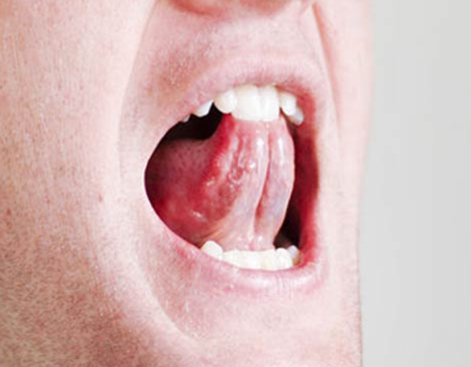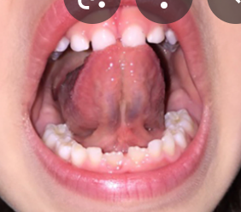

* **Suction Cup (aka lingual-palatal seal):** squeeze the body of the tongue up into the roof of the mouth and hold.  Goal is to maintain this position for 60 seconds without his tongue falling.  The edges of his tongue should be touching the inside of his teeth.

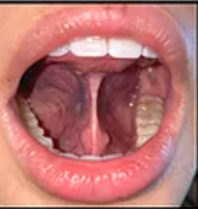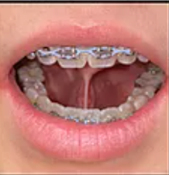

**Labial Exercises:**

* **Pucker-Smile:**  Pucker lips (focusing on maintaining symmetry between top and bottom lip) and switch to a smile, squeezing muscles while doing so.  Goal is to do this 20 times.
* **Pucker-Twist:** Pucker lips (focusing on maintaining symmetry between top and bottom lip) and twist the "kiss lips" side to side, focusing on symmetry.  Goal is to do this 20 times.
* See attached for example video

Please try to run through these 5 exercises at least 1x/day.  The more your child works on them, the more he will increase strength and coordination of these muscles.